Control strustures:

To execute the statements selectively we have togo for control structures …

1.if(condition)

{

If Body;

}

**If-else-if**

import java.util.*;

class Ifex

{

public static void main(String args[])

{

int num;

System.out.println("Enter a and b values");

Scanner sc=new Scanner(System.in);

num=sc.nextInt();

if(num==1)

System.out.println(" ONE");

else if(num==2)

System.out.println("TWO");

else if(num==3)

System.out.println("Three");

else if(num==4)

System.out.println("Four");

else if(num==5)

System.out.println("FIVE");

else

System.out.println("number outof limit");

}

}

**SWITCH**

import java.util.*;

class Ifex

{

public static void main(String args[])

{

int num;

System.out.println("Enter Number");

Scanner sc=new Scanner(System.in);

num=sc.nextInt();

switch(num)

{

case 1: System.out.println(" ONE");break;

case 2: System.out.println("TWO");//break;

case 3: System.out.println("Three");break;

case 4: System.out.println("Four");break;

case 5: System.out.println("FIVE");break;

default: System.out.println("number outof limit");

}

}

}

**Example 2:**

import java.util.*;

class Ifex

{

public static void main(String args[])

{

char ch;

System.out.println("Enter Number");

Scanner sc=new Scanner(System.in);

ch=sc.next().charAt(0);

switch(ch)

{

case 'a':

case 'e':

case 'i':

case 'o':

case 'u': System.out.println("vowel");break;

default: System.out.println("consonent");

}

}

}

**While**

import java.util.*;

class Ifex

{

public static void main(String args[])

{

int i;

i=0;

while(i<=10)//i will be called as loop control variable

{

System.out.println(i+"\t");

i++;

}

}

}

**Example 2:**

class Ifex

{

public static void main(String args[])

{

int i;

i=0;

while(true)

{

if(i==11)

break;

System.out.println(i+"\t");

i++;

}

}

}

**Example 3:**

class Ifex

{

public static void main(String args[])

{

int i;

i=0;

while(i<=10)

i++;

System.out.println(i+"\t");

}

}

**Example 4:**

class Ifex

{

public static void main(String args[])

{

int i;

i=0;

while(10)

i++;

System.out.println(i+"\t");

}

}

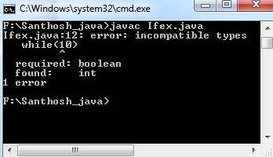

**Do while**

Syntax:

Do

{

Do while body;

}while(condition);

Note:

Irrespective of the condition the do while body will be executed atleast once..

**for**

syntax:

for(init;condition;inc/dec)

{

For body;

}

import java.util.*;

class demo

{

public static void main(String args[])

{

int num,r;

System.out.println("Enter the Number:");

Scanner sc=new Scanner(System.in);

num=sc.nextInt();

for(;num>0;)

{

r=num%10;

System.out.print(r+"\t");

num=num/10;

}

}

}

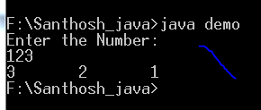

**Example 2:**

import java.util.*;

class demo

{

public static void main(String args[])

{

int num,r;

Scanner sc=new Scanner(System.in);

*for(System.out.println("Enter the Number:"),num=sc.nextInt();num>0;r=num%10,System.out.print(r+"\t"),num=num/10);*

}

}